|  |  |  |
| --- | --- | --- |
| **LAB221 Assignment** | **Type:** | **Short Assignment** |
| **Code:** | **J2.S.P0102** |
| **LOC:** | **50** |
| **Slot(s):** | **1** |

**Title**

Create a digital clock

**Background Context**

NA

**Program Specifications**

Create a program simulate a digital clock

***Function details:***

Display current time on the form in format: hh:mm:ss

***Expectation of User interface:***

The screen should be as:

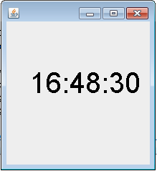

**Guidelines**